**DAY-4**

**EASY:**

**Write a C++ program to read and print students using simple inheritance**

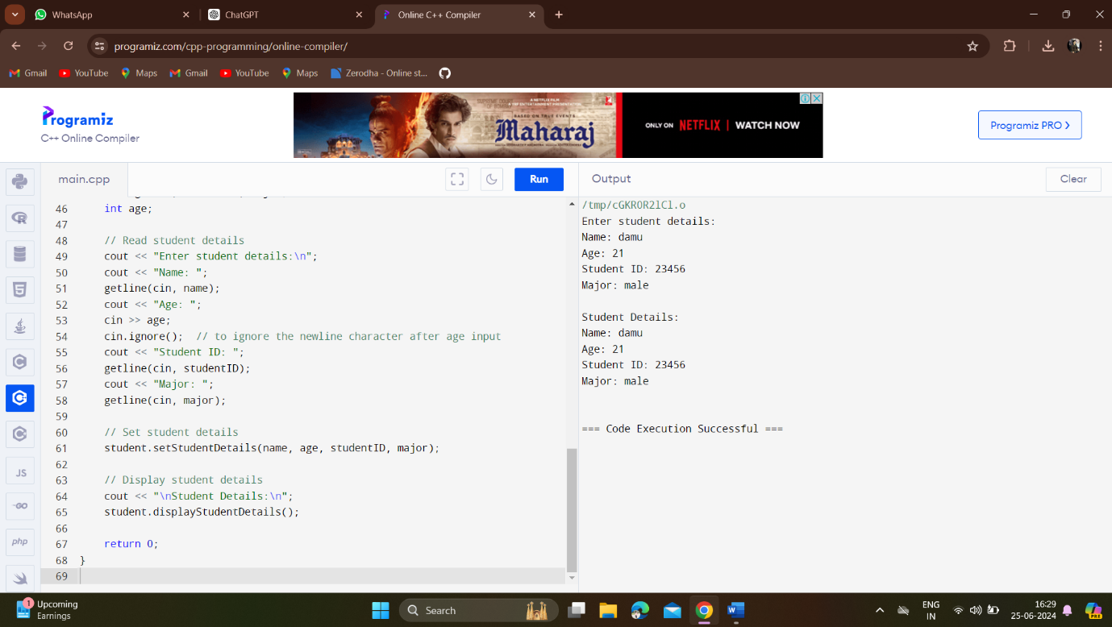

**Write C++ Program C++ program to demonstrate example of private simple inheritance**

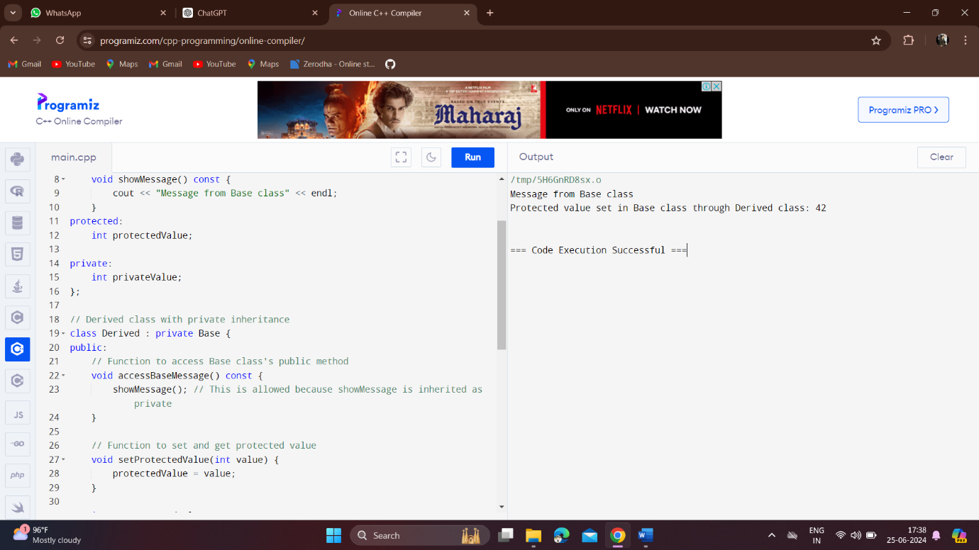**Write a program to build a C++ code to print the address of the variable.**

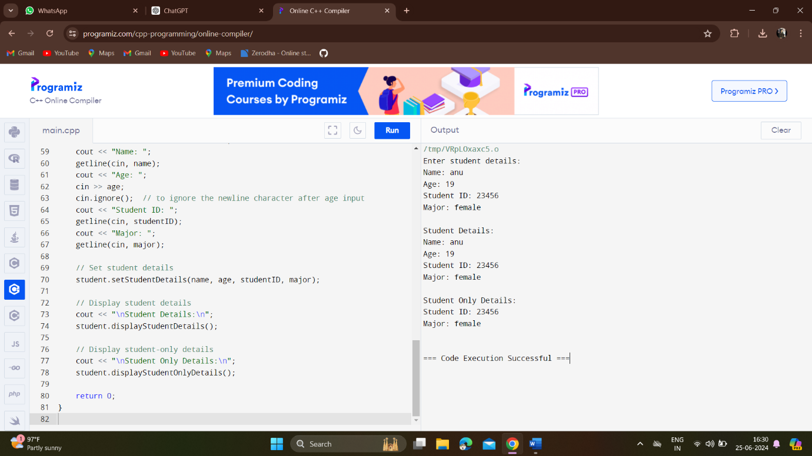

**Write a program in C++ to Program to demonstrate multiple inheritance** 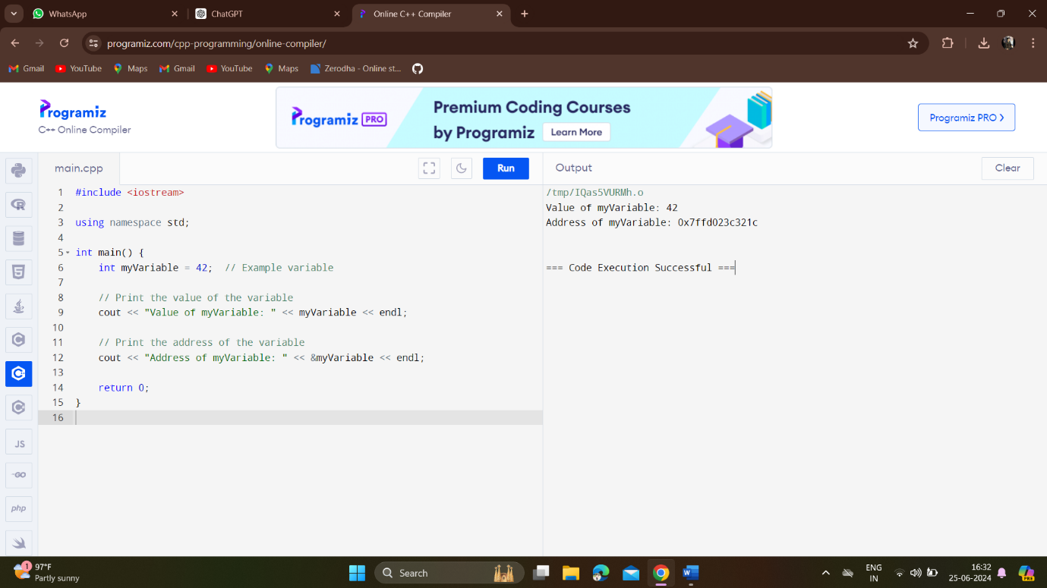

**. Write a C++ code to find area of square and circle using abstract class and pure virtual function**

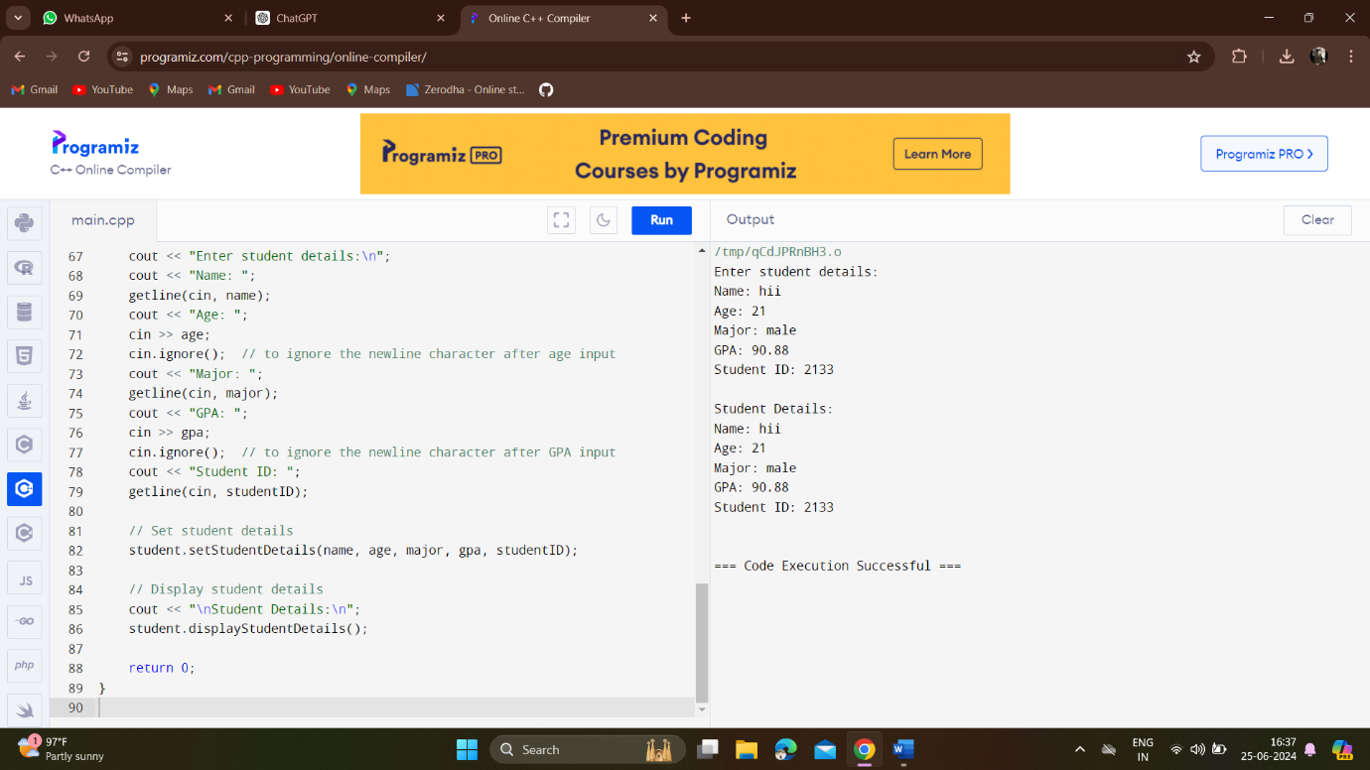

**Write a C++ Program that illustrates how to use ‘this’ pointer**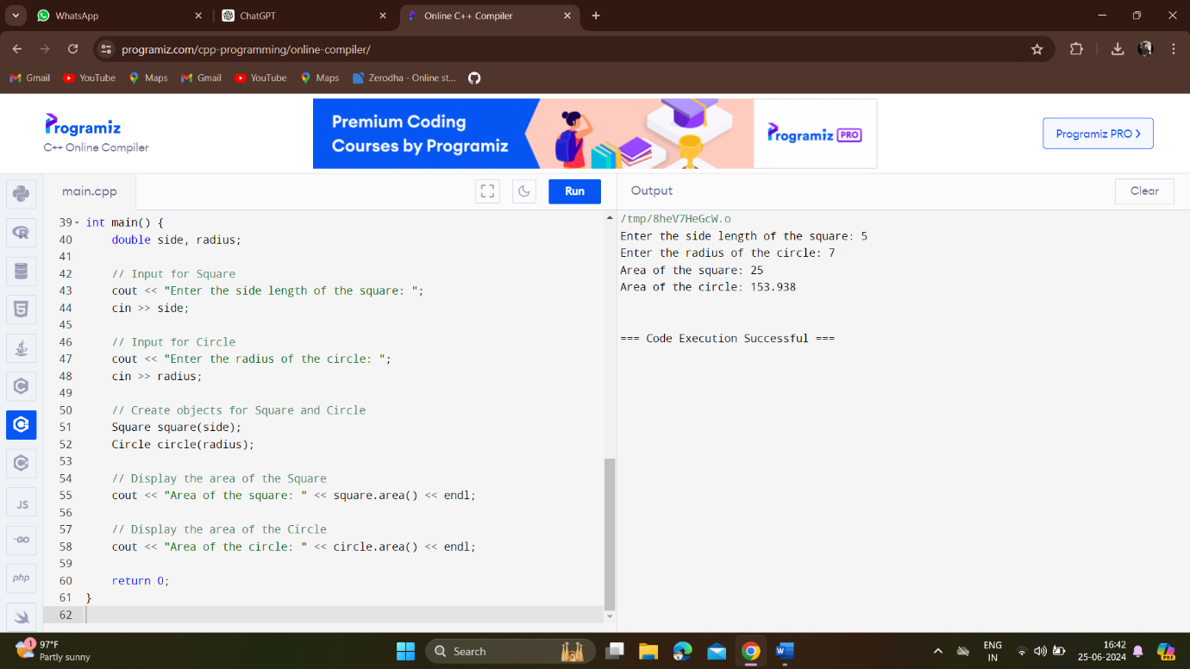

**Write a C++ Program to display address of each element of an array**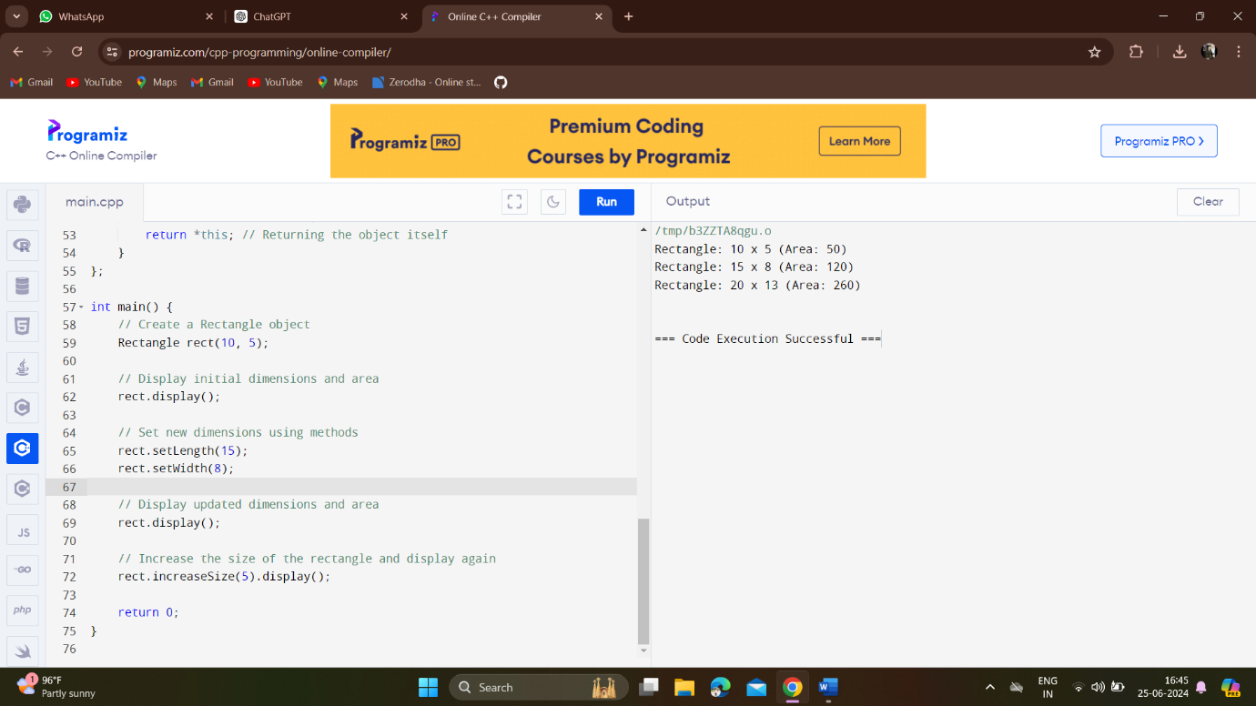

**Write a C++ program to find the sum of two numbers using the concept of C++ multiple inheritance**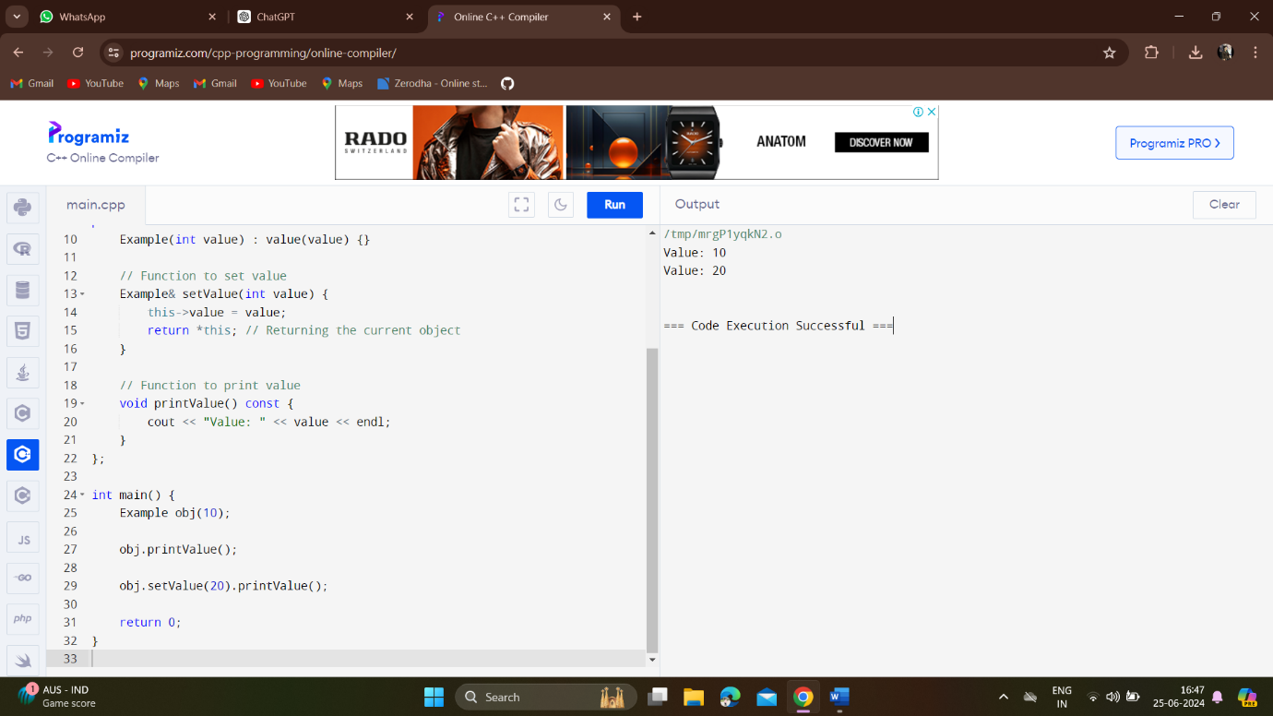

**Build a C++ code to find the area of a rectangle using the concept of array of objects.**

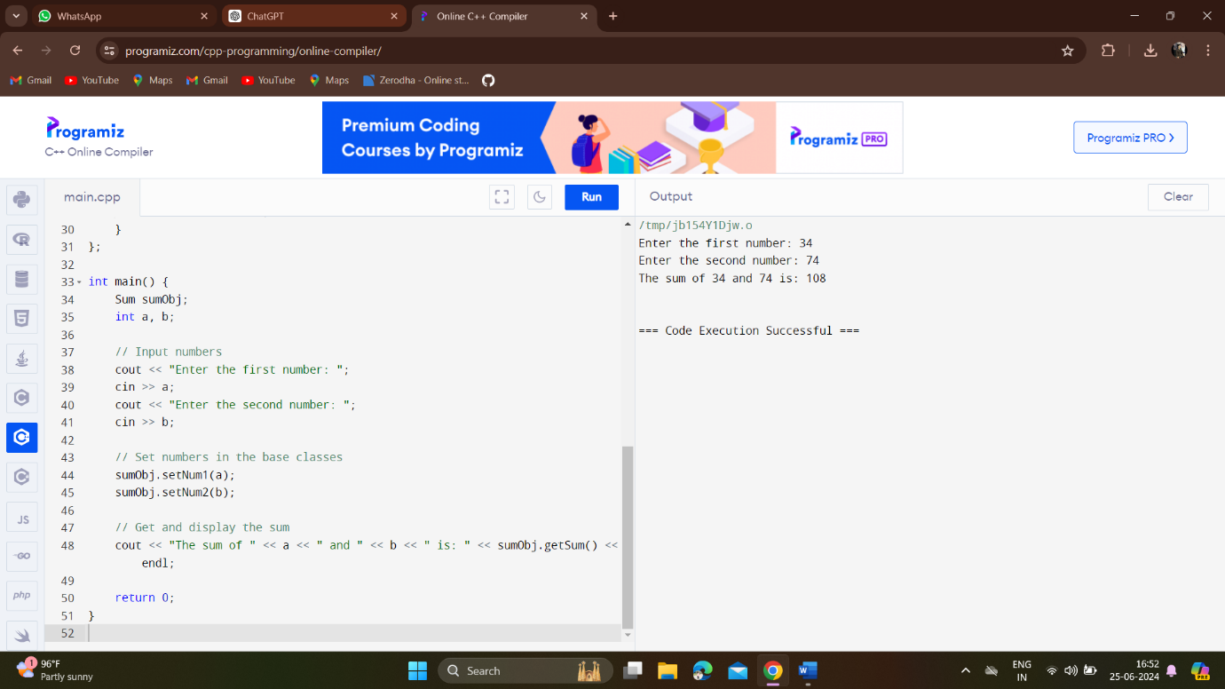

**Write a C++ code to print the given values in program using pointer to object**

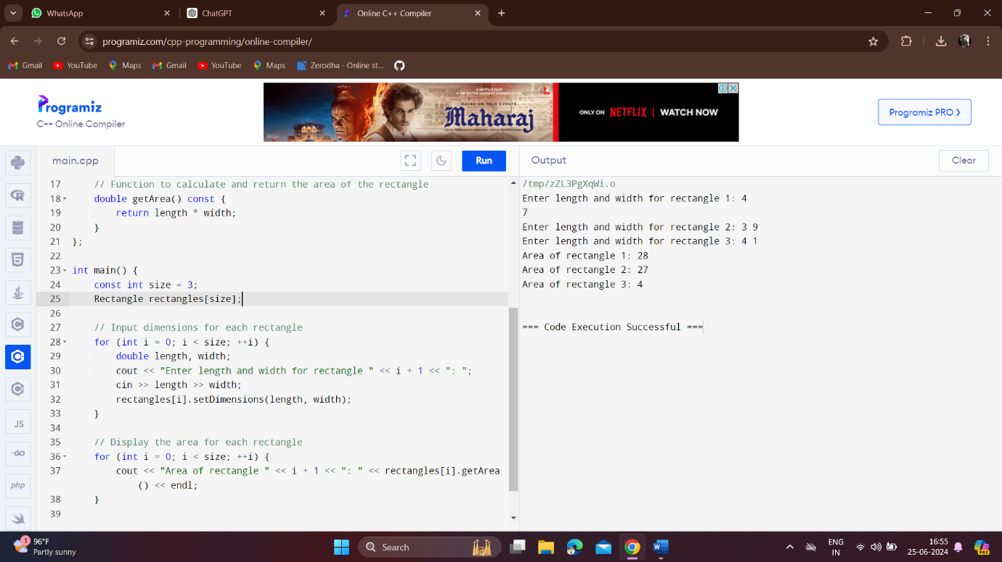

**MEDIUM:**

**Develop a C++ code to find area circle, rectangle and volume of cylinder using the concept of multilevel inheritance**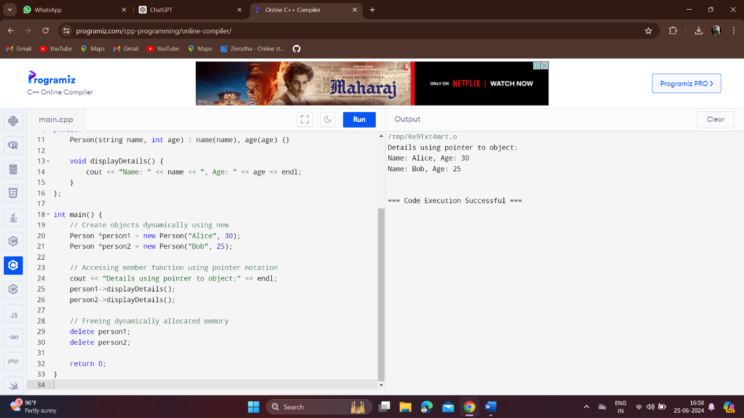

**Write a C++ program for employee details using an array of objects**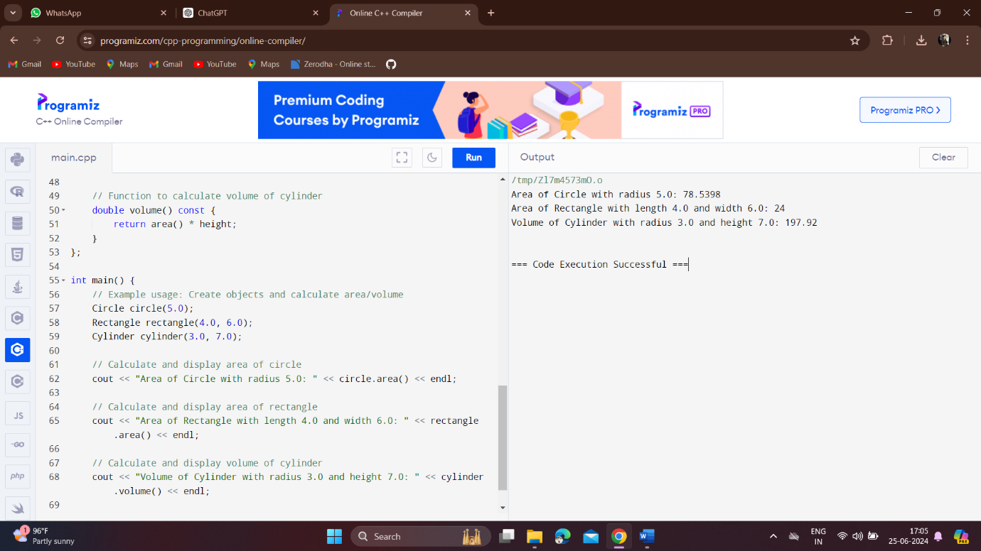

**Develop a C++ code to find to get square and cube of a number using Hierarchical inheritance**

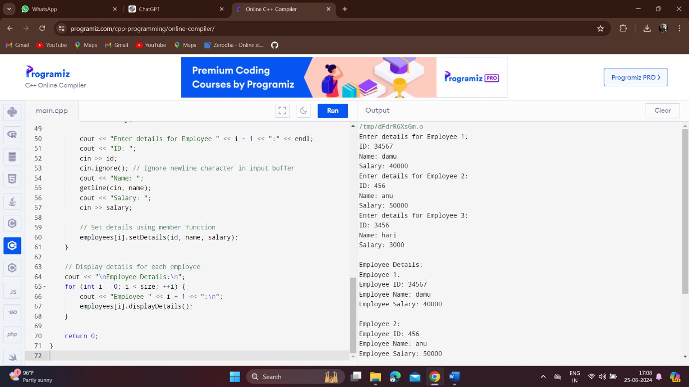

**Write a C++ Program to find the greatest of three numbers using pointers.**

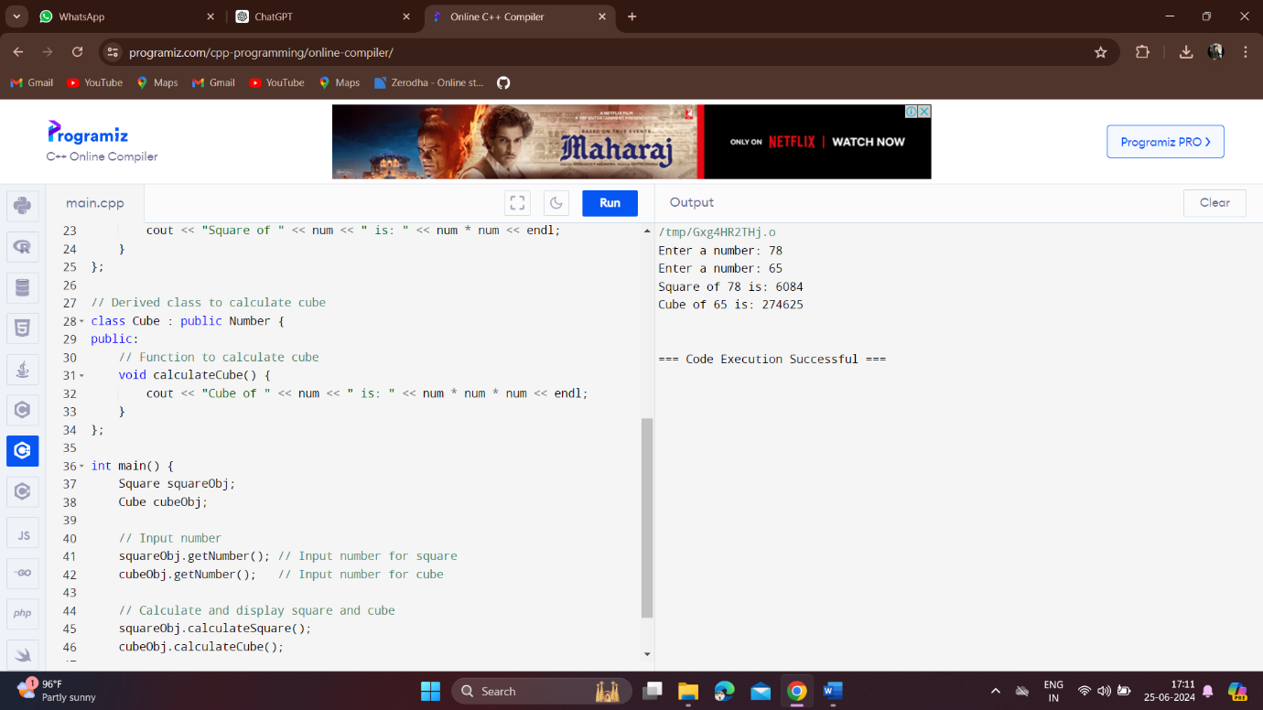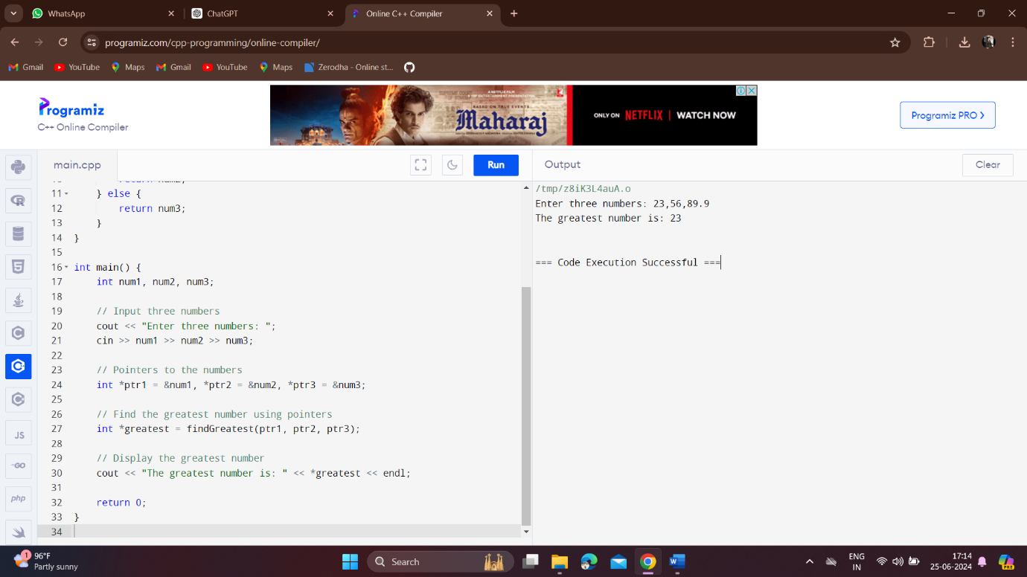

**Write a program in C++ to insert and display data entered by using pointer notation.**

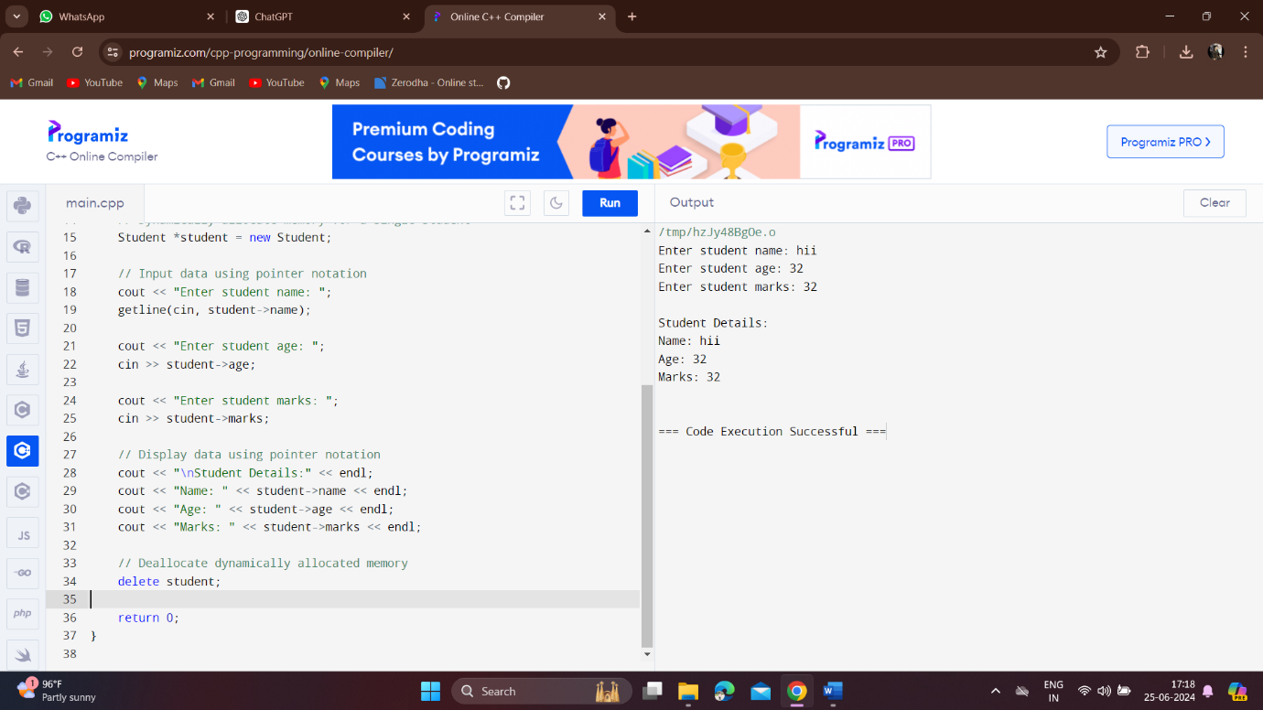

**HARD:**

**Develop a C++ code for a Bank management system using multiple inheritance**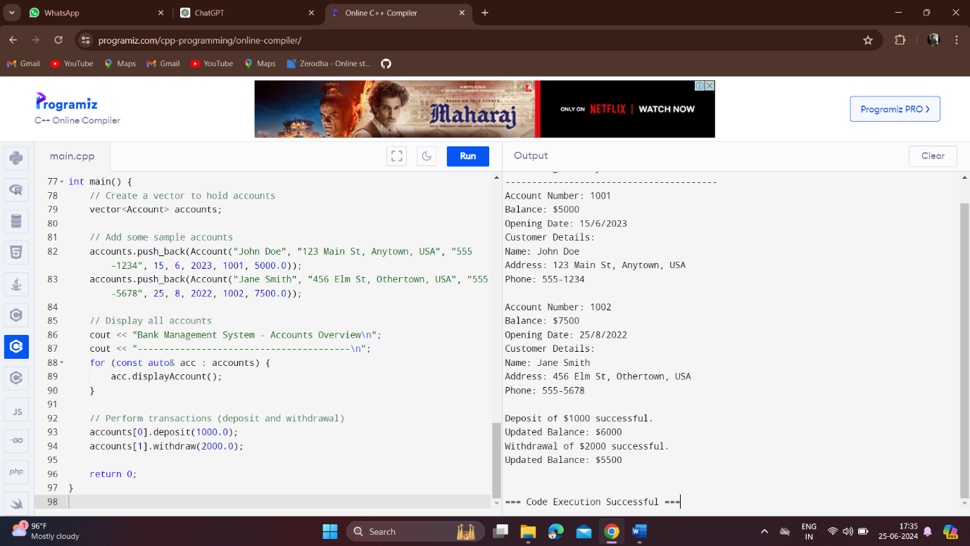

**Build a C++ program for student report using single inheritance**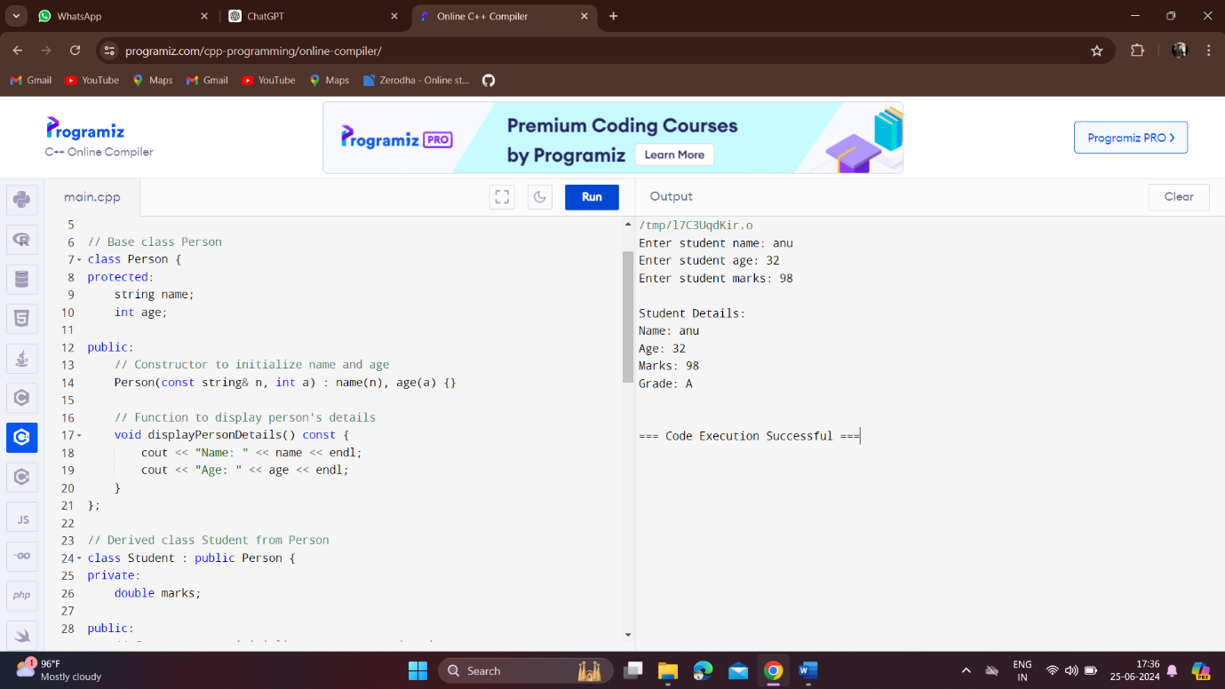

**Write a C++ code for Employee’s salary using hybrid inheritance** 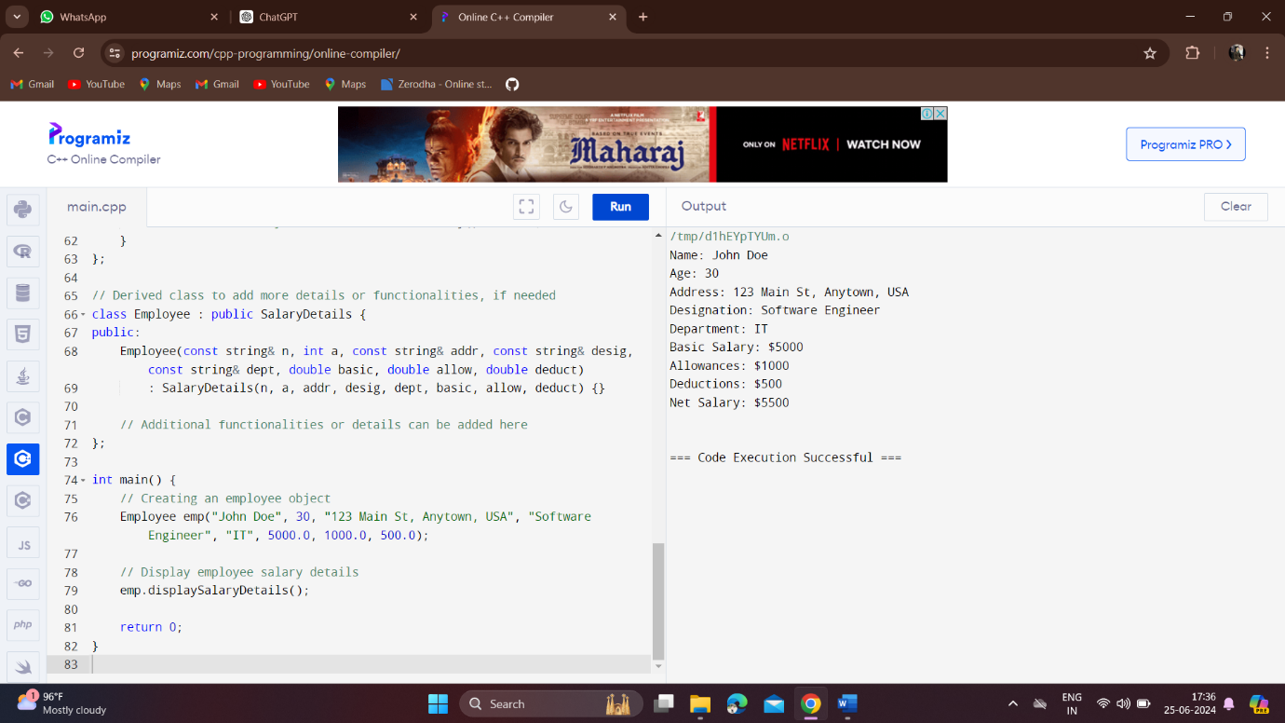

**Write a C++ program to sort the given list of elements in ascending using pointer**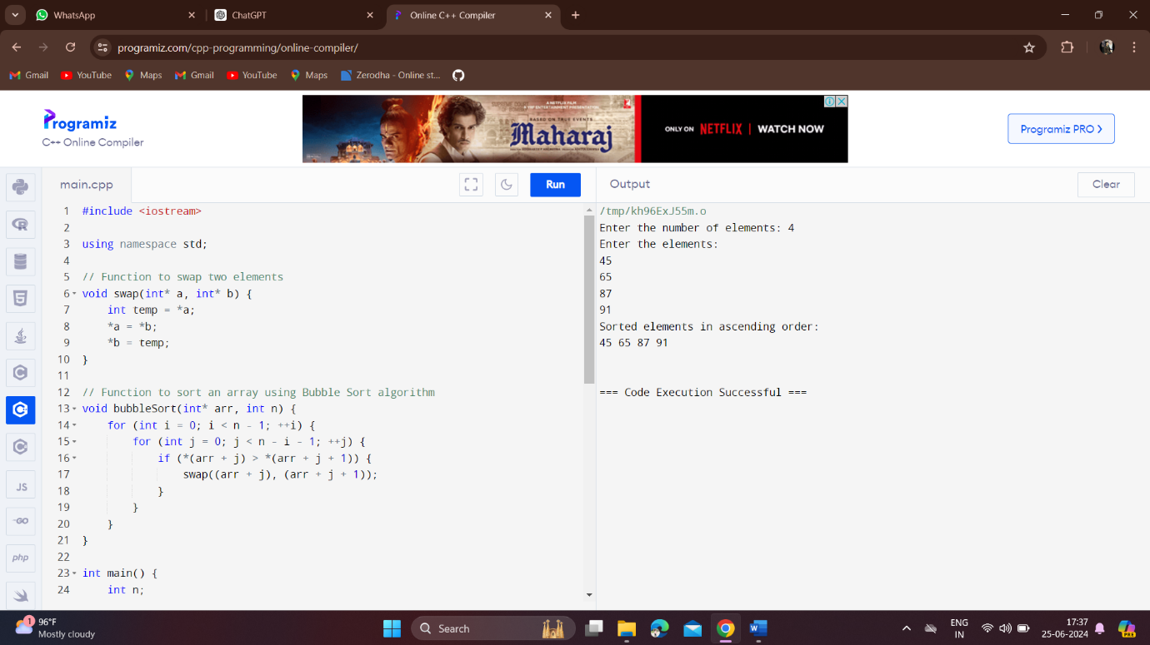

**Write a C++ Program for Enter Patient details using Inheritance**

